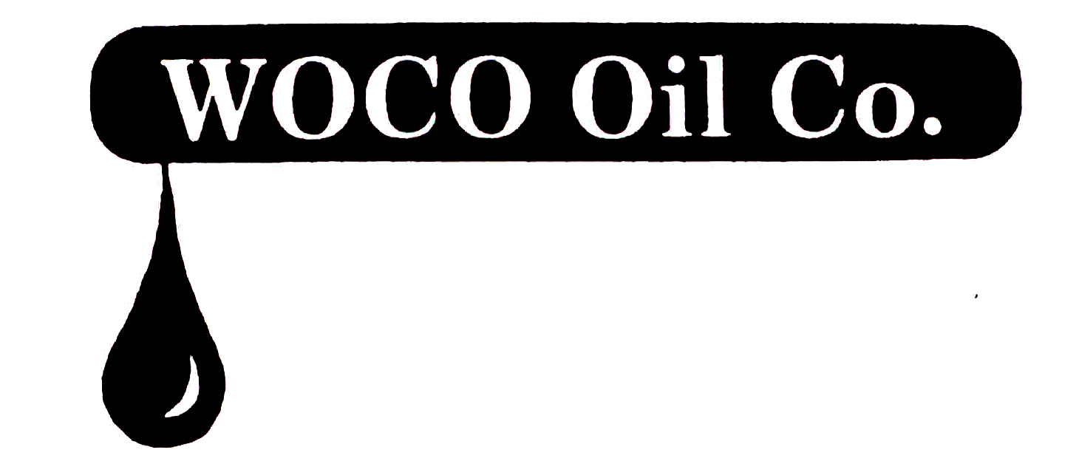

A Distributor of Petroleum Products

9080 Atlee Station Road
Mechanicsville, VA 23116
(804) 730-8353

November 01, 2019
Comments by WOCO Oil Company, Inc.
on
Transportation and Climate Initiative
Framework for a Draft Regional Policy Proposal
- WOCO Oil Company, Inc. (WOCO) employs four people and is strongly opposed to the "framework for a draft regional policy proposal" which seeks to expropriate the petroleum marketing industry. Over time this plan proposes to move Virginia from simple rationing and new taxes to the ultimate prohibition of fossil fuels.
- This plan does not assess the collateral damage it will inflict on state revenue, local tax collections, Virginia's Transportation Trust fund, and consumers.
- History has proven that rationing followed by prohibition - the ultimate goal of TCI - has led to black markets, unregulated and untaxed sales, and undue burdens on law enforcement.
- The impact of these proposals will not be solely on fuel sellers and convenience stores - what about the auto repair industry, muffler shops, service facilities at new car dealers, quick lubes etc.? What about agriculture, construction and watermen who will be forced to scrap present equipment or pay artificially high prices due to rationing? What about the consumer who will experience not only higher prices to operate their personal vehicles, but higher prices for consumer goods and services?
- WOCO strongly opposes the TCI plan to ration, tax and ultimately eliminate fossil fuels.
Sincerely,
David K. Walsh
David K. Walsh, President

