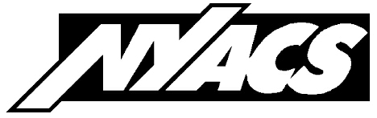New York Association of Convenience Stores
130 Washington Avenue, Suite 300, Albany NY 12210
TELEPHONE: (800) 33-NYACS or (518) 432-1400 ONLINE: www.nyacs.org

Comments of James Calvin, President
New York Association of Convenience Stores

concerning the

Draft Memorandum of Understanding

for the

Transportation and Climate Initiative

February 28, 2020

The New York Association of Convenience Stores is a statewide trade organization representing more than 5,000 neighborhood mini-marts that sell motor fuel at retail.
While we realize climate change must be addressed, and that everyone needs to be part of it, it’s hard for many of us in a legacy industry like motor fuel to embrace the prospect of abrupt, radical, punitive changes to our business model.
The Transportation and Climate Initiative draft MOU outlines broad parameters without providing specifics enabling us to meaningfully weigh the pluses and minuses. Its euphemistic use of terms “cap-and-invest” and “allowances” to obscure harsh elements of the system compound our skepticism.
In the interest of their businesses, their employees, and their customers, NYACS members are concerned about the potential for the TCI initiative to spawn motor fuel price spikes and/or supply disruptions that would have profound economic consequences.
This doesn’t make them anti-environment. To the contrary, New York convenience store operators redeem and recycle millions of deposit beverage containers annually, invest millions of dollars on upgraded petroleum storage and dispensing equipment to prevent groundwater contamination, and are constantly upgrading lighting and fixtures to reduce energy consumption and emissions.
While we see the merit in pursuing a zero-emissions marketplace, we don’t want our customers to become collateral damage on the pathway to that ideal. From the nebulous information in the MOU, we just can’t tell. It doesn’t even set forth a process for analyzing and mitigating the consumer impact of artificially inflating the cost of motor fuel.
We also need to know whether the new costs imposed on our industry will be equitably applied. Many of our upstate members operate stores near Native American enterprises that refuse to collect New York State and local taxes on the gasoline they sell to non-Indian motorists, leaving our members at a competitive price disadvantage. Will they be exempted from TCI-related cost hikes as well, widening the double standard?
We are not saying that the MOU should be rejected. We are saying that without more specifics, we are deeply concerned about the ramifications of lighting that fuse.

