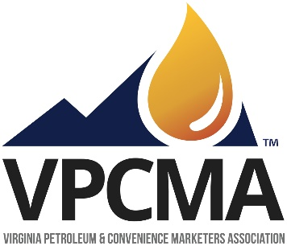

Virginia Petroleum and Convenience Marketers Association is a statewide trade association formed in 1948 representing the interests of the state’s petroleum and convenience industries. We are pleased to submit comments on the Transportation and Climate Initiative’s draft Memorandum of Understanding.
The facts are indisputable - TCI proposes to expropriate the petroleum marketing industry in Virginia and implement a program of rationing, taxation, and the eventual prohibition of fossil fuels for transportation purposes. Since its December release TCI has lost considerable support in the states, particularly in the Commonwealth of Virginia.
In our state, this ill-conceived plan will be rendered inoperative as the motoring public will avoid the additional taxes and rationing outlined in the draft Memorandum of Understanding by making their gasoline and diesel purchases across state lines in North Carolina, Kentucky, West Virginia, and Pennsylvania.
More importantly, the proposed program will eviscerate the state’s transportation trust fund and will in short order render Governor Northam’s proposed gasoline and diesel tax increases (which we support) moot. Further, TCI will endanger new funding for numerous proposed transit and rail enhancements which are largely dependent upon the pending motor fuels tax increases which TCI will eliminate.
In light of the precipitous decline in TCI’s support in Virginia and elsewhere, VPCMA would urge you to focus on alternatives that would accomplish our shared goal of a cleaner environment faster and at less cost. Some examples include assisting low income consumers to move from older energy inefficient vehicles to newer vehicles that are less polluting. A second would be to expand Virginia’s current fleet of propane school and transit buses. Propane buses are more efficient, far cheaper, and produce roughly the same environmental benefit as electric buses when costs of battery power production are factored in.
VPCMA is concerned that our previous comments on this issue were completely disregarded as were all similar comments opposing TCI emanating from the private sector. We trust this will not be the case with these comments on the draft Memorandum of Understanding. History demonstrates that attempts to control the public policy debate by ignoring those with opposing views are destined to fail. Virginia Petroleum and Convenience Marketers Association continues to strongly oppose TCI, but stands willing to work with any and all parties of good faith to achieve our shared goals of a cleaner environment and vibrant economy.

