# Comments on TCI [*Framework for a Draft Regional Policy Proposal*](https://www.transportationandclimate.org/sites/default/files/TCI-Framework_10-01-2019.pdf)

11/05/19

The Regional Policy Proposal should treat renewable fuels in a way that reflects their lower (or negative) greenhouse-gas emissions (GHG) and in ways that spur rural economic development, encourage renewable fuel adoption, and lower overall compliance costs.

Limiting the affected fuels and limiting the type of GHG to CO2 simplifies administration. The proposed program caps carbon dioxide (CO2) emissions from “finished motor gasoline and on-road diesel fuel” at the tailpipe. We assume that non-petroleum vehicle fuels (natural gas and propane) are outside the cap.

Biofuels reside in a “to-be-decided” realm (“…jurisdictions are evaluating whether and how to include and treat biofuels in the program”). Absent a way to treat biofuels in the program, they are deemed to contribute to CO2 as if they emitted the same net GHG as fossil fuels.

To account for biofuels and grow their portion of the fuel supply while limiting the administrative burden, we propose three options.

1. Exempt biofuels on a gallon-for-gallon basis as compared to fuels they are replacing.
2. Set aside allowances for renewable fuels, as mentioned in the “Auctions and Allocations” section.
3. Invest in infrastructure for renewable fuels in the same ways EV infrastructure would be an allowable investment.

Option 3 could complement options 1 -- 2.

We acknowledge that the EPA Renewable Fuel Standard (RFS) is designed to increase biofuel as a percentage of transportation fuel, and we note that the RFS distinguishes between types of fuels based on life-cycle emissions of GHG. Despite this regulatory mechanism, the use of ethanol, the main renewable fuel used in Vermont, has not changed since 2011. And according to VTrans, there is little potential for growth beyond the current use of ethanol at about 10% of gasoline volume.[1]

Nonetheless, as VTrans notes, the 2016 Vermont Comprehensive Energy Plan calls for an annual increase in biofuels use, from about 5.5% of transportation fuel use in 2015. Increasing biofuel use in transportation is based on achieving 90% renewable energy usage in Vermont by 2050 while also achieving Vermont’s GHG reduction goals.[2] There is no policy mechanism in Vermont transportation sector to achieve these renewable energy *and* GHG-reduction goals of the CEP.

By contrast, accounting for biofuels would increase their share of the fuel supply, lowering overall net emissions and thus the price of allowances at auction.

By at least exempting biofuels, TCI can spark economic development in rural areas, where such biofuels can be produced. For example, at least three states in TCI have abundant resources to make renewable natural gas (RNG). Back-of-the-envelope calculations show that Vermont’s dairy manure could produce enough RNG for about 1,000 heavy-duty trucks (Class 8). Together, New York and Pennsylvania have ten times the number of cows and thus manure as Vermont.

Bringing more RNG made from dairy manure into the vehicle fuel market has the side benefit of destroying methane, a powerful, short-lived GHG (twenty-year global warming potential of 84-87[3]). When made from dairy manure and used in vehicles, RNG is strongly carbon-negative on a life-cycle basis. See Appendix A for a comparison of vehicle fuels certified under California’s Low-Carbon Fuel Standard, including RNG from dairy manure.

Finally, we note that all diesel fuel could be placed outside TCI regulation. On-road uses of diesel account for 16-18% of the volume of all ground-transportation fuels in Vermont.[4] As described above, renewable-fuel options to displace diesel fuel have no policy that is effectively increasing their use, and without such policies, we can expect net GHG emissions from the freight sector to also remain steady. If TCI cannot account for and/or incentivize biofuels to displace diesel fuel, as it will do for electric vehicles, freight haulers will bear an inequitable burden compared to non-commercial users of fuel. An exemption from TCI would offset this unfair outcome, perhaps until TCI can develop a way to account for biofuels.

The Framework notes that jurisdictions have committed to equity and related goals along with reducing GHG. We recommend spending only on equity-related goals that reduce greenhouse gas emissions in the transportation sector or at least are strongly connected to such reductions.

Two examples:

* Rural mobility services, now often handled by community action agencies or volunteer networks[5]
* Targeting emissions reductions spending to areas of unhealthy air quality and low incomes

Transparency: we urge TCI’s MOU to include tracking CO2 reduction of all investments and set asides, enabling program adjustments and improvements. Failure to adhere to such provisions should be grounds to withhold funds and/or end a state’s involvement.

This echoes at least two of the commitments that TCI jurisdictions are making: “Developing complementary policies and priorities for carbon-reduction investments and continually improving the program.” “Making modifications and adjustments to the program design…” (page 2 of the Framework for a Draft Regional Policy Proposal”).

We are also keenly aware that states in which jurisdictions reside will be tempted to raid the investment funds and use them for non-TCI purposes, as has happened with energy programs in many states. TCI’s MOU should include language that withholds revenues and/or terminates a state’s relationship with the program. Withholding and termination could be structured to occur gradually so that states can plan their departure from TCI.

Appendix

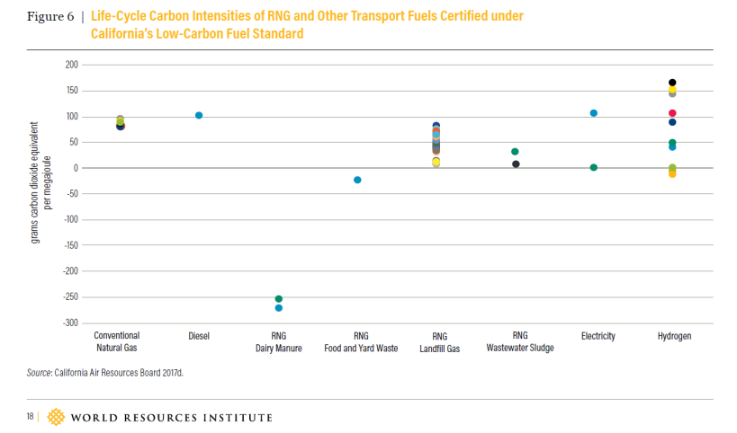

Page 18: <https://wriorg.s3.amazonaws.com/s3fs-public/production-use-renewable-natural-gas-climate-strategy-united-states.pdf>

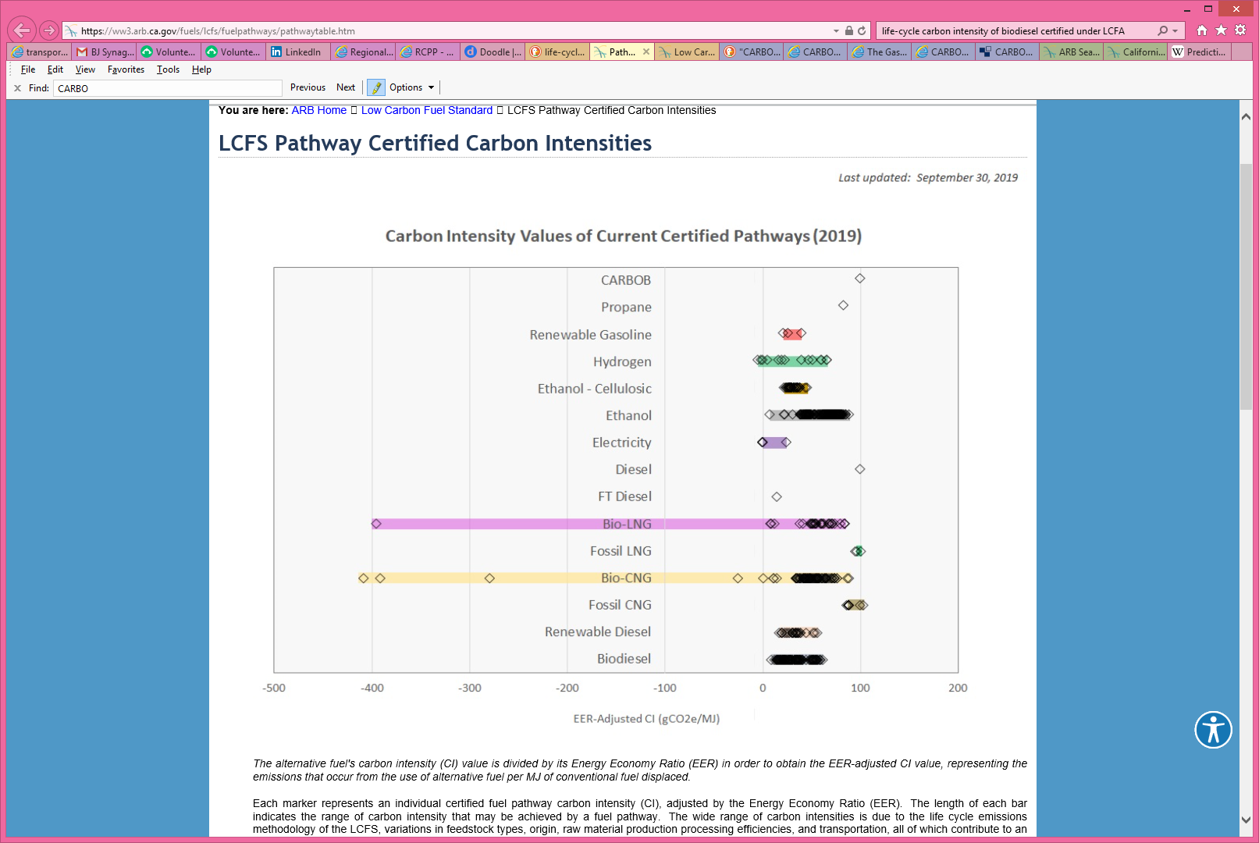

(gasoline)

<https://ww3.arb.ca.gov/fuels/lcfs/fuelpathways/pathwaytable.htm>

“CARBOB” = California standard gasoline, i.e. California Reformulated Gasoline Blendstock for Oxygenate Blending



*Comprehensive Energy Plan 2016*. <https://publicservice.vermont.gov/publications-resources/publications/energy_plan>

1. *The Vermont Energy Profile – 2017*, page 43: “Consumption of blended ethanol has been essentially stable since 2011. [...] There is relatively little potential for growth in blended ethanol sales in the near future. ... the CEP [the 2016 Vermont Comprehensive Energy Plan] does not support the promotion of E-85 infrastructure because of environmental concerns about ethanol production.”
2. *Comprehensive Energy Plan 2016*, page 38: “…this CEP establishes two goals for reduction in GHG emissions from Vermont’s energy use, which are consistent with the renewable energy and energy use goals also established here:

   40% reduction below 1990 levels by 2030;

   80% to 95% reduction below 1990 levels by 2050.”

   Page 39: “This section presents the modeling results from the Total Energy Study that inform DPS’s recommended sector-specific 2025 benchmark targets, introduced above in section 4.3. Exhibits 4‑7 and 4-8 depict an energy future in which the levels of end-use consumption of electricity and biofuels are each more than 70% greater in 2050 than they are today.*[footnote regarding the difference between Exhibits 4-7 and 4-8 omitted]* To reach this point would require average growth rates in usage of those fuels of more than 2% per year.” See Appendix for Exhibit 4-8, showing the illustrative scenario of increased biofuel usage to achieve renewable energy and GHG reduction goals.
3. <https://www.epa.gov/ghgemissions/understanding-global-warming-potentials>
4. *The Vermont Transportation Energy Profile – 2017*. Page 31. 2016 data.
5. See for example <https://www.cvcoa.org/rsvp.html>; “Meals on Wheels: Provide a nutritious meal, check on well-being, offer socialization and a smile – all in one delivery. […] Transportation: Help your older neighbors remain connected to their communities by providing rides to the senior center, grocery store and medical appointments.”