CT STAKEHOLDER INPUT ON OCTOBER 1, 2019

FRAMEWORK FOR A DRAFT REGIONAL POLICY PROPOSAL

October 12, 2020

Dear Transportation Climate Initiative Regional Policy Workgroup,

Thank you for the opportunity to provide input on the “Framework for a Draft Regional Policy Proposal” released on October 1, 2019. I support a regional policy to reduce transportation pollution and believe robust and meaningful public input into both the regional and state decision-making on the Transportation and Climate Initiative (TCI) is necessary to ensure a just and equitable policy design for Connecticut. I offer feedback on the proposal’s sections below.

Our current transportation system in Connecticut and throughout the Northeast is inequitable, prioritizing car ownership and ridership over all other forms of transportation. This has, in turn, created pollution of many kinds and has resulted in transportation as the largest sector of greenhouse gas emissions.

# Equity advisory committees

These committees are necessary to ensure accountability at all levels. It is essential that these committees have true decision-making power and include members from the relevant communities. To ensure participation from underserved and impacted communities, financial compensation for attending should be provided.

**Dedicated investments for** disproportionately **impacted communities**

At least 35% of investments, and ideally more than 50%, must be in disproportionately impacted communities to adequately address racial and economic justice issues. Antiracist discrimination, that is discriminating against people who are White in favor of Black and Latinx, is needed to make TCI an antiracist policy. More money must go to communities long left out of investment decisions to create equity. The Center for Latino Progress’s 2019 survey on TCI further indicates high support (82%) for prioritization of equity and environmental justice in investments, with 67% also supporting a dedicated percentage of investments going to address disproportionately impacted communities.

**Air quality monitoring as complementary policy**

Air quality monitoring is a necessary first step, but is the bare minimum needed. California’s model is a precedent for Connecticut, setting air quality improvement targets and strategies in individual communities and, through grants, empowers community organizations to facilitate this process. Because air quality is often worst in low-income communities and those with high percentages of Black and Latinx residents, the MOU should commit to lowering pollution in these communities.

**Workforce training and employment**

Creating good jobs in environmentally beneficial sectors is one of the most promising aspects of TCI. It is essential that strong labor standards are upheld and that job preference is given to those in environmental justice communities. Especially in this current age of COVID, well-paying and stable jobs are in short supply; TCI opens opportunities for high-quality jobs. TCI can and should also encourage apprenticeship and training programs.

Sincerely,

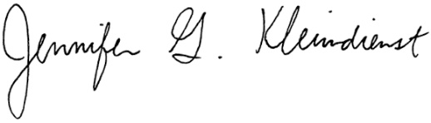

Jennifer G. Kleindienst

241 West St.

Middletown, CT 06457