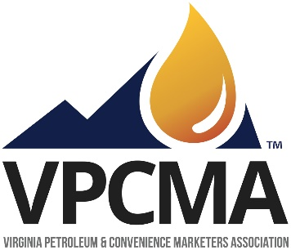

Virginia Petroleum and Convenience Marketers Association is a statewide trade association formed in 1948 representing the interests of the state’s petroleum and convenience industries.  We are pleased to submit comments on the Transportation and Climate Initiative’s draft Model Rule.

This version of the plan ignores the fact that two thirds of the anticipated TCI states have made the decision not to sign on to this program. Ignoring reality, the unelected bureaucrats and academics affiliated with the Georgetown Climate Center have moved full speed ahead with a plan which neglects the pandemic’s impact on emissions, redistributes wealth, expropriates the petroleum marketing industry and will likely bankrupt state transportation funding in the near term.

TCI proposal is to expropriate the petroleum marketing industry in Virginia while at the same time implementing a program of rationing, taxation, and the eventual prohibition of fossil fuels for transportation purposes. In the course of American history, except in times of World War citizens have rejected rationing and prohibition and this proposal will see the same fate.

In our state, this ill-conceived plan will be immediately rendered inoperative as the motoring public will avoid the additional taxes and rationing of motor fuels imposed by TCI. Drivers will take their gasoline, diesel and incidental purchases across state lines to North Carolina, Kentucky, West Virginia, and Pennsylvania.  The result will be less revenue than Virginia collects today. How does TCI plan to make up the difference?

We would caution TCI to not continue its efforts to manipulate public opinion on this issue by engaging in push polling by a firm that has already endorsed the concept.

Electrification is not the answer. This plan will generate far less revenue for transportation than the state’s motor fuel tax does presently. When and if electric cars become more prevalent in the state (there are about 25,000 today) each will be paying a user fee of $98 annually, less than half of what is collected today from Virginia motor vehicles.

More importantly, the proposed program will eviscerate the state’s transportation trust fund and will in short order render moot bipartisan gasoline and diesel tax increases enacted by the General Assembly in 2020.  Further, TCI will endanger new funding for numerous approved proposed transit and rail enhancements which are largely dependent upon the recently enacted and pending bipartisan motor fuels tax increases.

In light of the precipitous decline in TCI’s support in Virginia and elsewhere, VPCMA would again urge the Georgetown Climate Center to focus on alternatives that would accomplish our shared goal of a cleaner environment faster and at less cost.

Bipartisan consensus could surely be achieved quickly on a plan that would incentivize low-income consumers to move from older energy inefficient vehicles to newer vehicles that are less polluting.  A second program that has already been embraced by many states would be to expand Virginia’s current fleet of propane school and transit buses. Propane buses are more efficient, far cheaper, and produce roughly the same environmental benefit as electric buses when costs of battery power production are factored in.

VPCMA is concerned that our previous comments (and most others in opposition) on this issue were completely disregarded. Given that TCI has asked for public comment from all sides of this debate, we hope that will not be the case in 2021.   History shows us that attempts to control the public policy debate by ignoring those with opposing views are destined to fail.  Virginia Petroleum and Convenience Marketers Association continues to strongly oppose TCI, but stands willing to work with any and all parties of good faith to achieve our shared goals of a cleaner environment and vibrant economy.